**Digital Lock for Clinical Refrigerators**

Biomedical Engineering Senior Design

Dr. Aijun Wang

Progress Report 1

Fall 2023

Team 1

Miguel Cruz-11:08 am, 10/29/2023

Brayden Chipman-12:13 pm, 10/29/2023

Ashwin Halepet-12:38 pm, 10/30/2023

Vance Padilla - 3:38pm, 10/29/2023

Table of Contents

**Problem Formulation 2**

A. Background 2

B. Design Problem Statement 3

C. Objective 3

**Needs Assessment 4**

A. Survey Results 4

B. Needs Flow Chart 5

**State-of-the Art 7**

A. Introduction 7

B. Patent and Literature Search Results 7

C. Benchmarking Table 12

**Preliminary Engineering Design Specifications and Constraints 1****5**

A. EDS Table 15

B. House of Quality 16

**References 1****8**

**Appendix 1****9**

User Needs Survey R1 19

Additional Patents Chart 22

Client Interview 22

Meeting Minutes 24

Gantt Chart 25

# 

# Problem Formulation

## Background

In preclinical and clinical laboratories, refrigerators and freezers are necessary tools for the preservation of samples such as biopsies, antibodies, and enzymes for use in testing and research. In certain situations, these samples can be irreplaceable. Unintentional thawing of these samples may render them unusable for the lab, leading to large losses in both time and money.

Refrigerators have gaskets, which are straps that are on the internal edge of the refrigerator door that seal the refrigerator shut. Inside a gasket is a magnet that uses attraction to shut itself to the metal of the refrigerator in order to seal shut [4]. Additionally, a refrigerator has hinges in order to close properly as well as open and close in a specific direction [6].

Refrigerators can fail to close for a variety of reasons, regardless of whether the refrigerator is in a laboratory environment or not. For instance, refrigerators could potentially lose the sealing capabilities of the gasket (the sealing that helps close the refrigerator door) due the gasket being dirty and old [5]. This can reduce the refrigerator’s capabilities of keeping shut. Another reason why the refrigerator might not be closing is because there are too many items inside the refrigerator and the items could prop the refrigerator door open in order to fit in. In environments where the internal temperature of the refrigerator or freezer is below freezing, ice buildup can also prevent the doors from properly closing. Furthermore, the refrigerator's magnets that can attract the metal of the refrigerator could potentially not function as well as usual, which results in the door potentially not closing properly [3]. Additionally, the refrigerator hinges can be damaged, which can prevent the refrigerator door from closing since the door cannot move properly if the hinges fail to operate properly [6]. Finally, another reason why a refrigerator door will not close is due to human negligence where a person did not shut it tightly enough or did not close it all the way [2].

To prevent this, many refrigerators have displays to show the internal temperature or alarms that go off when the temperature gets too low. Despite this, however, lab refrigerators still get left open often. A reason for this is likely because by time the displays show the low temperature, people are either gone or not paying attention and the samples are compromised. Additionally, alarms may not go off until after hours or may fail. If the equipment is old, it also may not have these features. If the refrigerators still work, a lock would be a cheaper and easier upgrade than installing alarms or displays.

Laboratories are environments in which the potential for human error can be very high. Laboratory refrigerators hold samples and materials that can potentially be worth hundreds of thousands of dollars in materials and research time. Based on client testimonials, laboratory refrigerators have been unintentionally left open, leading to large monetary losses.

## Design Problem Statement

Current locking systems for laboratory refrigerators and freezers fail to provide sufficient barriers to human error that would prevent the doors from being left ajar accidentally. Simple mechanical locks may ensure that the doors stay shut, but they lack network integration that would allow for users to verify that the door is shut properly or who has opened the refrigerator recently. The only current solution we have found that solves both issues is sold at a price that is not feasible for many labs, as most labs would have to buy multiple to ensure the integrity of their entire inventory[1]. This solution is the Beol Smart Lock as shown in the Benchmarking Table section. At $984 USD this lock is not feasible to order for the majority of labs. There are other digital locks on the open market that a consumer can buy. Such as on Amazon, where some locks can connect to personal devices and track worker’s usage of the locks (to better figure out who may have accidentally left the door open). However, none of these locks can be used on refrigerators without compromising the structure of the door. A digital refrigerator lock would have to exist solely on the exterior of the refrigerator system.

For these reasons, we aim to create an affordable digital device to increase security with refrigerated products by holding lab members accountable for ensuring the refrigerator door is shut.

## Objective

The objective of this senior design project is to develop a digital locking system for laboratory refrigerators and freezers that seamlessly interfaces with a dedicated digital application. We will provide a comprehensive solution that enhances the security and accountability of laboratory refrigerators. By addressing these major requirements and design inputs, the project aims to develop a digital locking system that is accessible, user-friendly, and cost-effective for a diverse range of laboratories.

Needs Assessment

## Survey Results

There is a disclaimer for the survey that was conducted by our team that responses from either us or the teaching assistant will be weighted as less than any other responses. Additionally, there are elements of the survey that we conducted that will be improved upon in future renditions of the survey in order to improve user feedback for the project’s user needs. We will make the survey more broadly to serve the needs of various customers since owning lab refrigerators is a very broad category of different users rather than needs based on only our client. We will base our survey more on the general needs of the users potentially impacted by digital locks in refrigerators rather than what aspects the customers desire for the end product. Furthermore, we plan on adding more text to the front of the survey in order to make it clearer on what the survey will accomplish.

The survey respondents of this survey vary from professors to teaching assistants to students. Besides ourselves and our teaching assistants, any other responder will be held in equal weight. However, due to some changes in how we will make our survey, any new responses will hold more weight than before since the new survey will be more polished and it will address problems with our survey. The current survey questions were planned to gauge user interest of needs and possible elements for the design; however, the new survey will go over more user needs. The questions that will be held in the most weight are the free response questions since a person can clarify and respond to their reasoning on why they weigh certain problems or needs more than others and it will help us gauge what is most important and what is the extent of the problems and needs users are facing. Our current survey based user needs off whether a user need is very important, useful but not important, and not important, which are defined as: very important means the user need is absolutely necessary for the design or else the design will not be as beneficial to users, useful but not important means the need is more nice to have but is not required, and not important means that the need is not essential to the final design.

Based on the survey results, the majority of the users do not have any form of locks or securing mechanism to secure their lab refrigerators. A slight majority of users have had their refrigerators open at least once throughout their time in a laboratory environment. Some users indicate a lack of worry with their refrigerators as they have not had issues with refrigerators opening. However, other users have had problems with their refrigerator security either through older parts of the refrigerator or due to unreliable alarm and lock systems. The survey responders universally indicated that they desire a lower priced product in order to save money as well as a smaller product anywhere up to a maximum size of a foot.

## Needs Flow Chart

The most important requirement is to safeguard the integrity of valuable laboratory samples. The digital lock system will provide a remote locking and unlocking mechanism for refrigerator doors, directly addressing the critical user need to prevent unintentional spoilage of samples due to doors being left ajar. A primary design input is the creation of a system capable of reliably protecting these valuable, often irreplaceable, samples.

Another core consideration is the prioritization of personnel accountability. This requirement calls for the integration of digital features that enable real-time user logs and remote alerts. By tracking and recording personnel interactions with the locking mechanism, the project aims to enhance accountability within laboratory settings. The design input focuses on creating a digital application that seamlessly syncs with the locking system, facilitating user management and monitoring.

Additionally, cost-effectiveness is a key aspect of the objective. The project aims to design an affordable solution that overcomes the high price barriers associated with existing locking systems. This design input aligns with the overarching need for an economical digital device that improves security and accountability, ensuring accessibility for laboratories of varying sizes. Cost-effectiveness also ties into another direct need from end users, that being the longevity of the product. It is a major benefit to end users to have a product that will not have to be replaced for some time.

In addition to these major requirements, there are other considerations that, while not primary requirements, would be valuable inputs for the design of the locking device. A user-centric approach is something to consider, with the aim of creating a user-friendly interface that simplifies the process of remote locking and unlocking. In the process of making this product more accessible, interacting with the locking system becomes easier. This however, is not a characteristic that would drastically impact the functionality of the product. This approach addresses the need for an intuitive digital application and locking mechanism design, making it easy for laboratory staff to use.

Compatibility and integration are also considerations for the design. The digital lock system should seamlessly fit a wide range of refrigerator models commonly found in laboratories, addressing the diversity of laboratory equipment. The design inputs will focus on ensuring compatibility and integration capabilities.

Security was one of the characteristics that was not a priority for many, given the survey results. Given that the primary clientele of this product is laboratory staff, there was not as much a concern of stealing, rather a concern that the refrigerator doors stay closed. As a result, physical barriers towards theft and physical damage were not of a higher priority.

Below is shown the needs flow charts which summarizes what considerations are essential to not needed.

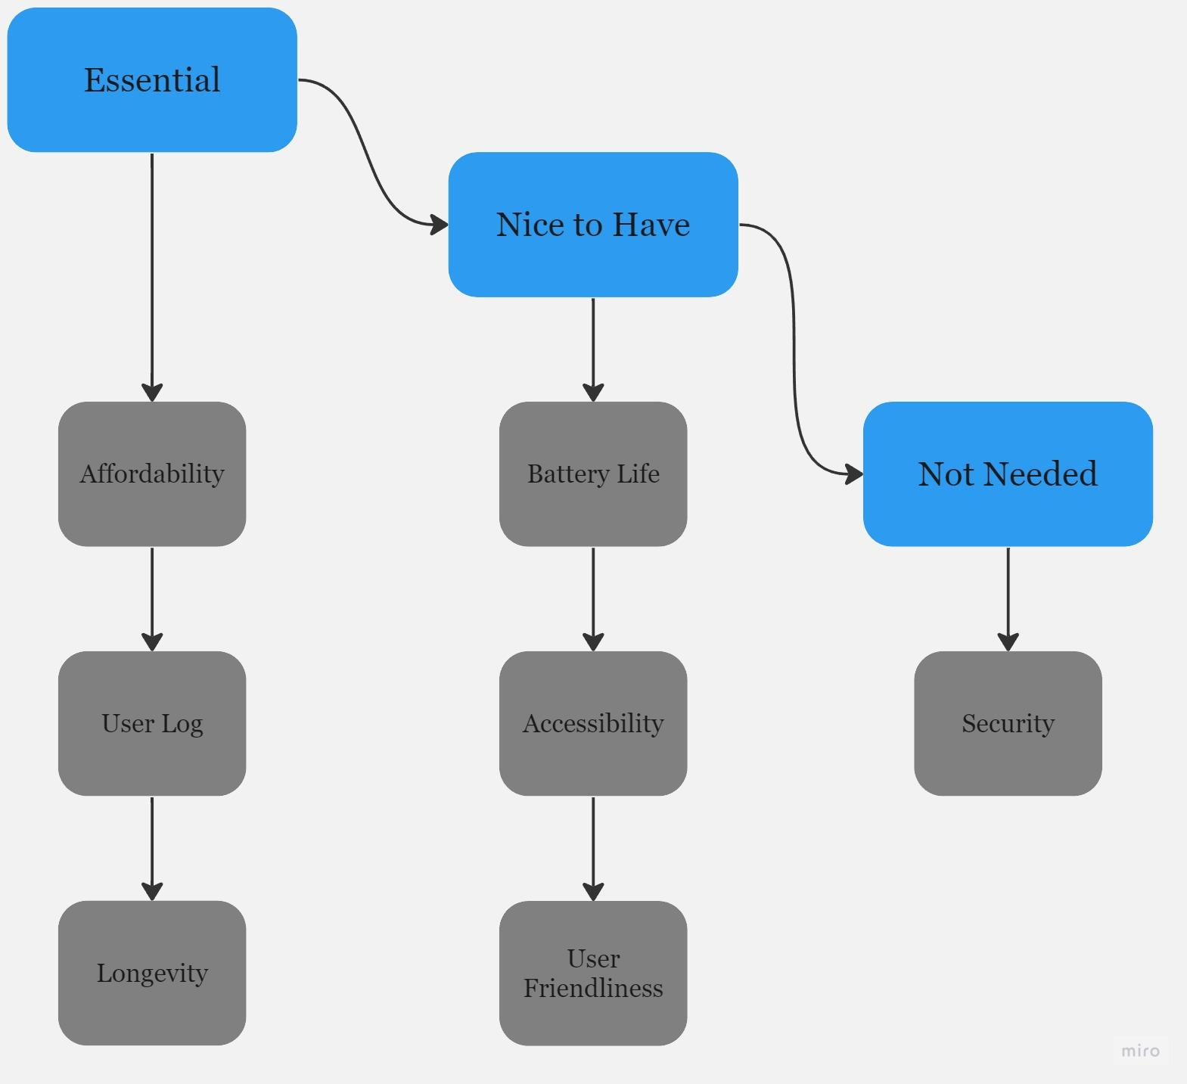

# State-of-the Art

## Introduction

While there have been some similar refrigerator lock products on prior patents, including some with digital unlocking and locking systems, none have had digital locks that connect internet enabled devices. Aside from that, these devices have features that we could draw inspiration from for our digitized refrigerator locks, as well as information on what features are missing from the current market.

## Patent and Literature Search Results

1. US20210071940A Patent

i. Cooler and Freezer Lock

ii.William Denison, Calin Roatis

iii. The product is a lock that can be utilized to open and close a freezer. Access is controlled with controllers that can unlock and lock the refrigerator door. There is a digital component to these locks as each controller is controlled by a microcomputer. Furthermore, there is an electronic system in the device in order to help perform the unlocking and locking actions. A drawback of this system is that the lock is a complicated design that can confuse users. This product can serve as inspiration for our potential device since the digital lock will be an electronic system and we can base our product on this in order to gain inspiration on how to create an electronic designed digital lock.

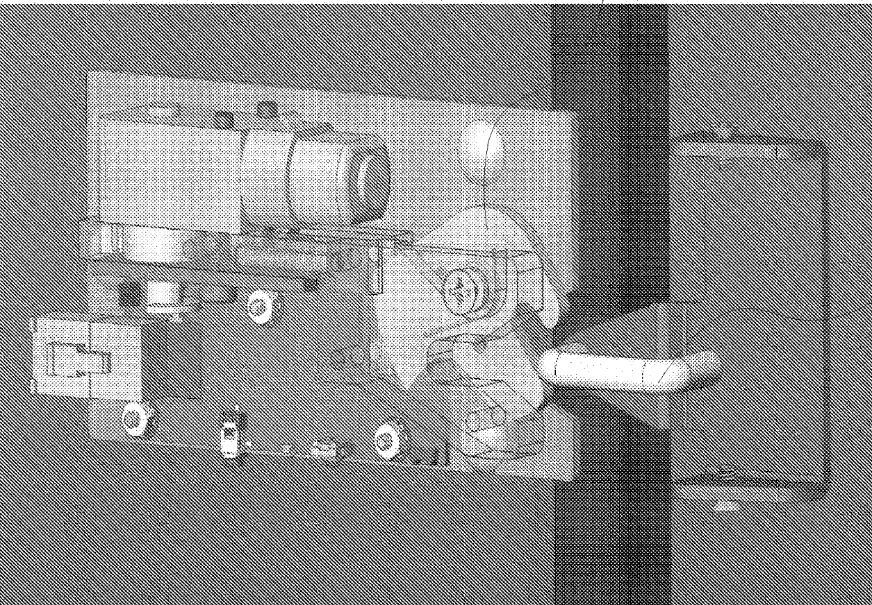

1. US7768378B2 Patent

i. Field retrofittable refrigerator lock with audit trail

ii. Brian R. Hill, Steven A. Belzek, Robert Brewcyznski, Kenneth A. Kaczmarz, Mitchell S. Mlynarczyk, Francis H. Zimmerman, Ernest Vaughn

iii. The product is a refrigerator lock with a number punch-in code attached on the front of the lock in order to secure the refrigerator with a passcode. The product contains digital components due to the punch in code that resembles a phone. The product can track user information, as well as when the user opened and closed the refrigerator. The main drawback of this product is that the phone system that is used is rather dated and most people use more digital versions of phones in this day and age. However, this product can serve as inspiration since this product uses a phone network, similarly to how a digital lock has a phone like interface within a digital app, in order to ensure the lock is locked.

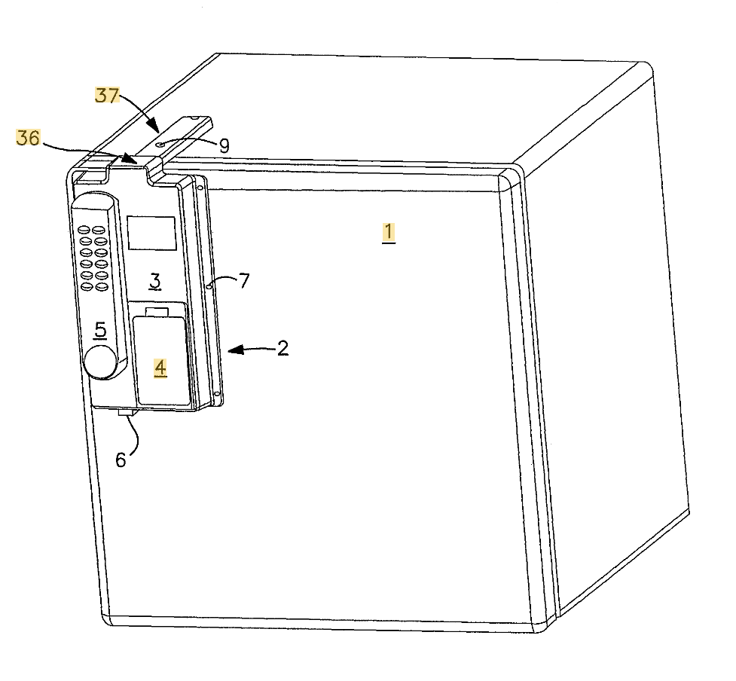

1. US8063735B2 Patent

i. Remotely actuated refrigerator lock with thermal spoilage protection

ii. Norman A. Shoenfeld

iii. The product is a remote door lock system that can be accessed via a computer. The product can be connected to a computer either by ethernet or by a USB system. The product can track the temperature and humidity within the system so that when the temperature and humidity reaches a threshold, the remote connected unlocking and locking will be disabled in order to regulate temperature and humidity. This product also maintains a log of people who access the refrigerator. The biggest drawback of this design is that it is a rather large device that does take up space. This design is relevant to our brainstorming process since this design is remotely controlled and that it connects to devices via some form of an external network.

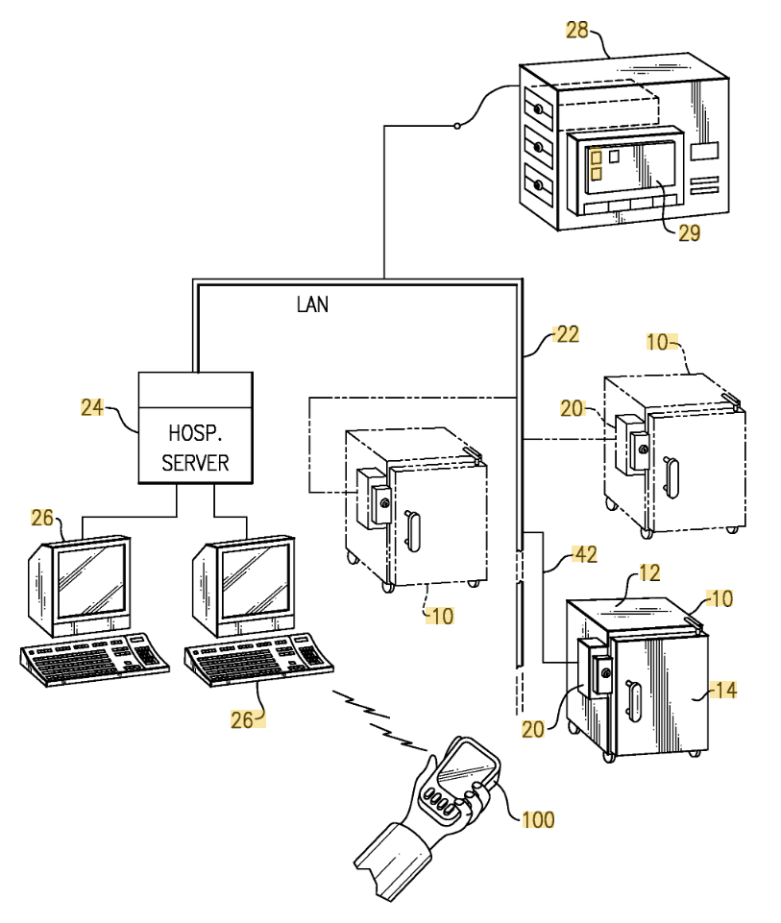

1. US20170219271 Patent

i. Refrigerator Locking System

ii. Carl Kent Abrahamson

iii. This product is a lock that can lock multiple doors of the refrigerator at once in just one location of the refrigerator. This is a quite versatile lock since it can close a number of locks at once in the same refrigerator cabinet while not requiring any additional devices or parts. A drawback of this device is that there is not anything digital about this device. This could serve as inspiration for if we decide to expand the product and create a device that can close multiple refrigerator doors at once.

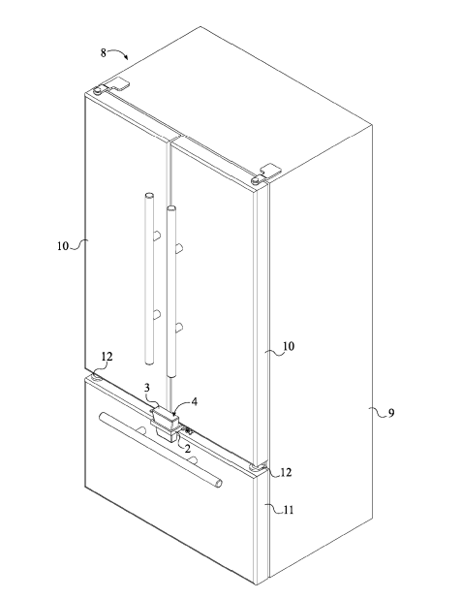

1. Becton Dickinson Pyxis ES Refrigerator

This device is a refrigerator that stores medications and encodes in the users so that the doctor knows who uses what medicine that is stored in the refrigerator as well as the location. This device requires signing in and signing out in a screen that is on the refrigerator in order to access the medication, hence why this device is a digital lock. Furthermore, this device has a physical key spot so that a person could also access it with a physical key. There are various versions and sizes of this device depending on user needs. A drawback of this device is that the screen has a lot of options and it can get complicated when looking for the basic items since the screen keeps a vast log of medications and users, though it is only a light drawback. This device can serve as inspiration for our future device since it can give us ideas on how a sign in feature can work on our app as well as some ideas on aspects of the app to add.

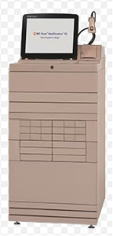

There have been previous recalls on digital refrigerator unlocking and locking devices used for storing biological and/or medical substances, though they are limited in frequency. There have been prior problems where a user signs in to access the refrigerator and the refrigerator does not open. According to MAUDE, in 2021 and 2022, there has been one recorded incident in both years for the Becton Dickinson Pyxis ES Refrigerator, where the refrigerator refused to unlock due to a malfunction, and as a result, a customer could not get their medications that the doctor prescribes, even though in one of the cases, the patient refused treatments. This is a very serious recall since if a patient needed to get their needed medicine, if the refrigerator refuses to unlock, then the patient could ultimately die since they could not get their medicine. Our digital lock should automatically open when a user chooses the unlock option as well as have a physical override.

## Benchmarking Table

Due to the specificity of the problem that this project is meant to address, a benchmarking table was created in order to compare the important metrics of similar products. The benchmarking table is a neat and convenient method to collect ideas on what one can expect in terms of price and other metrics based on similar devices. The user needs that were chosen were based on survey results as well as team discussions with each other, the Teaching Assistant, and the client. The benchmarking table compares similar products’ solutions to user needs along with their metrics and units. The BEOL Biological Refrigerator Smart Lock was chosen to be benchmarked and compared due to the fact that it is the only current digital locking solution for refrigerators in a laboratory setting that is on the market, even though they only sell in China and the pricing is high. Due to the high feature set and price of the BEOL lock, this lock can be considered very useful yet very niche. The goal of this project is to make a more widely accessible lock while still maintaining much of the specialized functionality that comes with network and remote integration. The reason the Sifely Smart Lock was chosen is because the product is a digital lock used for any lock that connects to a phone app. While not direct competition for the product this project seeks to create, the Sifely Smart Lock sets a general guideline for features and a user interface that users are satisfied with in regards to remote control of the lock and with everyday usage. The YEYA Refrigerator Lock was chosen based on the information that it was one of the best selling refrigerator locks on Amazon, a shopping service that would be widely available to people both in and out of labs. By using this device as one of the products to benchmark, one is able to compare current user needs to a general refrigerator lock without any digital capabilities, similar to a control group in an experiment.

| **BENCHMARKING TABLE 10-20-23** | | | | | |
| --- | --- | --- | --- | --- | --- |
| TEAM 1: Brayden Chipman, Miguel Cruz, Ashwin Halepet, Vance Padilla | | | | | |
| **Need** | **Metric** | **Units** | **BEOL Biological Refrigerator Smart Lock \*** | **Sifely Smart Lock** | **YEYA Refrigerator Lock** |
|
| 1 | Cost | US Dollars | $984 | $129.99 | $13.99 |
| 2,4,6,7 | Remote Connectivity | Binary | Yes | Yes | No |
| 4,7 | Size | Centimeters | 15.9 cm x 8.8 cm x 3.6 cm | 17.78 cm x 7.62 cm x 2.84 cm | 25.4 cm x 6.60 cm x 2.54 cm |
| 3,7 | Material | Type | PC-ABS engineering plastics | Zinc | Polypropylene Plastic |
| 3,7 | Strength | Young's Modulus of Material(MPa) | 1670-11100 MPa | 96500 MPa | 800-8250 MPa |
| 3,4,6,7 | Method of Attachment | Type | Adhesive | Installation on Door | Adhesive |
| 4,5,7 | Power Delivery | Type | 2 AA Batteries | 4 AA Batteries | N/A |
| 2,6,7 | Method of Verification | Type | NFC Card, physical key, remote authorization | App, Fingerprint, Passcode | Key |
| 7 | Alarms/Notifications | Binary | Yes | Yes | No |
| 4,6 | Weight | Kilogram | ~3 kg | ~1.65 kg | 0.2 kg |
| 4,6 | Used Outside of Labs | Binary | No | Yes | Yes |
| 1 | Affordability | *Translated using DeepL Translation | |  | |
| 2 | Records |  | |
| 3 | Longevity |
| 4 | User Friendly |
| 5 | Battery Life |
| 6 | Accessibility |
| 7 | Security |
| Images | | |  |  |  |
| Description of Products | | | This is a digital lock that was specifically designed for biological refrigerators. It includes a temperature monitor, and features that can close the lock based on changes in temperature. | This is a digital lock that has unlock and lock features connected to a mobile application used to replace the traditional lock and doorknob system. | This is a non-digital lock that is held by a thick wire. The black squares are held up by adhesives that stick to the refrigerator. |

# 

# Preliminary Engineering Design Specifications and Constraints

## A. Target Values

This is the current rendition of the preliminary engineering design specifications table. Each of the design metrics was created with one central user need in mind. However, due to the overlapping nature of the needs and properties required to satisfy those needs, most metrics have interplay with each other. One example of this would be the metrics relating to the attachment of the device, as the method of attachment is also directly related to the strength of that attachment.

Given the feedback from the user needs survey, the metrics that were of high importance to the product’s design were size, price, remote connectivity, notifications, method of attachment, strength of attachment, strength of material, user log, and weight. The size and weight of the device were determined through an average of the competition. The device should be small and light enough to be easily installable, yet not to the point where the device loses physical strength. Therefore, by averaging the values of known products that successfully accomplish their task, the product has a starting point in terms of size and weight. Price was a major concern for a large portion of the survey respondents, and the maximum price was determined to be 300 USD. The closest device to the product that this project is meant to create is the BEOL Biological Refrigerator Smart Lock, which is sold at nearly 1000 USD. Obtaining similar functionality at around 300 USD would make this product much more attractive towards consumers with multiple refrigerators that need to be secured. The user log, notifications, and remote connectivity are all metrics that were decided to be nearly essential to the functionality of this project, and were only present on the expensive BEOL lock. By allowing for users to have access to these more modern features, this product is meant to bridge the gap between the very expensive, feature rich locks and the standard physical locks that are commonly used in older or less funded labs.

| Metrics | Units | Corresponding User Needs | Range | Target Value | Direction of Improvement |
| --- | --- | --- | --- | --- | --- |
| Size | Centimeters | User Friendliness | 2cm-30.48cm | 16.0 cm x 8.0 cm x 4.0 cm | To be minimized to a point |
| Price | US Dollar | Affordability | $14-$984 | $~300 | To be minimized |
| Remote Connectivity | Binary | User Friendliness | N/A | Yes | N/A |
| Notifications | Binary | Accessibility | N/A | Yes | N/A |
| Method of Attachment | Type | Longevity | Adhesive or Installation | Acrylic Based Adhesive | N/A |
| Strength of Attachment | N | Durability | 100-200 | 135 | N/A |
| Strength of Material | GPa | Durability | 0.8 to 96.5 | 69 (6061 Aluminum) | To be maximized |
| User Log | Binary | Records | N/A | Yes | N/A |
| Weight | kg | User Friendliness | 1 kg to 4 kg | 2 kg | To be minimized |

## B. House of Quality

After creating a benchmarking table to help compare important metrics of similar products and creating an engineering design specifications table (EDS), combining both tables together will create a house of quality. Not only does the house of quality provide many of the details from both the benchmarking table and the EDS table, the house of quality helps us understand the technical aspects within the customers requests and how each metric focused on affects other metrics required for this device. The house of quality also provides relative weight prioritization and customer importance that is judged based on survey responses. Benchmarking and EDS data is mostly displayed on the bottom.

The house of quality helps greatly with correlating between needs and functional requirements. The table shows that the needs of affordability, user friendliness, and security have many strong relationships with the functional requirements. The house of quality also shows that remote connectivity, and material heavily affect the needs that customers want. The table also displays correlations between each functional requirement. Cost and strength of attachment have many correlations to consider when developing the product. Material, cost, and method of attachment will greatly affect the strength of attachment positively while the use of this product outside of labs may correlate with a decrease in cost. Based on the needs shown on the survey, users request many functional requirements to be improved which are all shown on the house of quality. Remote connectivity, power delivery, method of verification, alarms/notifications, and use outside of labs want to be greatly improved while cost of the product wants to be greatly decreased.

## 

# 

# References

1. “BEOL贝尔科技生物冰箱智能锁 报警智能冰箱锁 电子锁.” *百度爱采购 - 国内优质的批发采购平台、货源批发网、进货渠道*, Qingdao Bell Intelligent Technology Co., Ltd., Accessed 28 Oct. 2023.
2. Appliance, Advanced. “The Fridge Door Won’t Close Properly: Reasons & Solutions.” *Advanced Appliance Repair Service*, 27 Feb. 2023, Accessed 28 Oct. 2023.
3. “10 Ways to Repair a Refrigerator Door That Won’t Close.” *Flamingo Appliance Service*, 16 July 2019, Accessed 28 Oct. 2023.
4. Blumberg, Perri Ormont. “Why You Should Clean Your Refrigerator Door Gaskets ASAP.” *Southern Living*, Dotdash Meredith, 3 Feb. 2020, Accessed 28 Oct. 2023.
5. Crabb, George. “How to Remagnetise a Fridge Door Seal - FIRST4MAGNETS: Blog.” *FIRST4MAGNETS*, 30 Mar. 2023, Accessed 28 Oct. 2023.
6. Rheuby, Dev. “Selecting the Best Refrigerator Door Hinges: What You Need to Know.” *HingeOutlet*, HingeOutlet, 6 June 2023, Accessed 28 Oct. 2023.
7. “Maude Adverse Event Report: CAREFUSION 303 Pyxis Es Refrigerator; Automated Dispensing Cabinet.” *Accessdata.Fda.Gov*, FDA, Accessed 28 Oct. 2023.
8. “Maude Adverse Event Report: Marion Veterans Affairs Medical Pyxis ES Refrigerator; Automated Dispensing Cabinet.” *Accessdata.Fda.Gov*, FDA, Accessed 28 Oct. 2023.
9. “Overview of Materials for Polypropylene, Molded.” *MatWeb*, Accessed 28 Oct. 2023.
10. Denison, William, and Calin Roatis. “US20210071940A1 - Cooler and Freezer Lock.” *Google Patents*, Google, 11 Mar. 2021, Accessed 28 Oct. 2023.
11. Hill, Brian R., et al. “US7768378B2 - Field Retrofittable Refrigerator Lock with Audit Trail.” *Google Patents*, Google, 3 Aug. 2010, Accessed 28 Oct. 2023.
12. Shoenfeld, Norman A. “US8063735B2 - Remotely Actuated Refrigerator Lock with Thermal Spoilage Protection.” *Google Patents*, Google, 22 Nov. 2011, Accessed 28 Oct. 2023.
13. Abrahamson, Carl Kent. “Refrigerator Locking System .” *Free Patents Online*, Anaqua, Inc., 3 Aug. 2017, Accessed 28 Oct. 2023.
14. “Pyxis Medstation ES System .” *50136*, Becton Dickinson, June 2013, Accessed 28 Oct. 2023. 50136.com.au/wp-content/uploads/2016/03/Pyxis-Medstation-ES-Station-User-Guide.pdf.

# 

# Appendix

## **User Needs Survey R1**

Our group utilized Google Forms in order to conduct a survey of various questions. We conducted the survey in order to gain insights on what are the most important user needs to keep in mind during the project. Additionally, we used the survey to understand the extent of the problems with lab refrigerators being left open. Below are the questions that were used in the survey.

**Part 1: Introductory Questions**

Our group will be conducting a senior design project on creating a digital lock system in order to ensure that refrigerators in the lab are secured. Occasionally in labs, the refrigerator accidentally gets left open, and the consequences can be devastating since open refrigerators can compromise hundreds of thousands of dollars in research. To help prevent this, our group will create a lock that is connected to an app so the lock can secure the refrigerator from being left ajar or slipping open, as well as being able to limit access to selected personnel.

The main information that will be needed for this project are the current issues with locking systems for lab refrigerators and ways that users wish to use the device digitally. We also need other information about possible features that, while not necessary, may be wanted by enough people.

This survey is designed to gather information about needs and wants important to potential end users of our product.

What is your name and email?

Does your lab use locks or any securing mechanism to make sure the refrigerators stay closed?

* Yes
* No

If you answered yes to the previous question, answer the following questions:

Please describe your current system of securing your refrigerator.

What are some issues you have experienced with your current system?

**Part 2: User Needs For The Digital Lock**

This section is for figuring out the priorities of the end users based on the current locking solutions.

How often have the lab freezers/refrigerators accidentally stayed open throughout your time in the lab?

* 1-2 times
* 3-4 times
* 5 or more times
* Never

Based on your current refrigerator lock solutions, please list the top three design elements that were insufficient in your experience.

Please explain why these features are insufficient.

Please explain your experience with security around your lab.

**Part 3: Future Design Elements**

This section is about your priorities in looking at possible future design elements for a digital refrigerator lock. Please state your level of priority by selecting one of the three following options: Very Important, Useful But Not Important, and Not Important.

How important is it to be able to monitor the temperature of the refrigerator and have it notify you?

* Very Important
* Useful But Not Important
* Not Important

How important is it to have an app that is associated with the digital lock to record usage of the refrigerator or turn on/off the lock on the refrigerator?

* Very Important
* Useful But Not Important
* Not Important

How important is it that the lock be very difficult to break into?

* Very Important
* Useful But Not Important
* Not Important

How important is the ability for the digital lock to open or close refrigerator doors remotely?

* Very Important
* Useful But Not Important
* Not Important

Based on the previous questions, explain why what you chose is of high priority.

If you would like to explain other priorities that have not been listed, please explain here. Please provide your experience on why this is a priority.

**Part 4: Design Input Target Values**

When constructing this lock, what are some restrictions that might need to be considered during the design process?

What is the highest price range you would be willing to pay for this product?

* $0-$150
* $150-$300
* $300-$450
* Greater than $450

What are the maximum dimensions for the lock system (full height, width, and depth)?

Are there any other specific details and restraints that one should consider when constructing this refrigerator lock?

**Part 5: Free Response**

Please give any final statements that you believe must be considered when creating a refrigerator lock. All concerns or ideas will be considered for this project.

Write down any other questions, concerns, or any other essential ideas that have not been listed that you have about this digital lock app project.

## 

## 

## **Additional Patents Chart**

| **Patent Number** | **Title** | **Inventor** | **Current Assignee** | **Source** |
| --- | --- | --- | --- | --- |
| US20210071940A | Cooler and Freezer Lock | William Denison, Calin Roatis | Individual | <https://patents.google.com/patent/US20210071940A1/en?oq=US20210071940A> |
| US7768378B2 | Field Retrofittable Refrigerator Lock with Audit Trail | Brian R. Hill, Steven A. Belzek, Robert Brewczynski, Kenneth A. Kaczmarz, Mitchell S. Mlynarczyk, Francis H. Zimmerman, Ernest Vaughn | CompX International Inc | <https://patents.google.com/patent/US7768378B2/en?oq=US7768378B2US7768378B2> |
| US8063735B2 | Remotely Actuated Refrigerator Lock with Thermal Spoilage Protection | Norman A. Shoenfeld | S&S X Ray Products Inc, SIS X Ray Products Inc | <https://patents.google.com/patent/US8063735B2/en?oq=US8063735B2> |
| US20170219271 | Refrigerator Locking System | Carl Kent Abrahamson | Individual | <https://patents.google.com/patent/US20170219271A1/en?oq=US20170219271> |

## **Client Interview**

We met with our client twice. The first meeting was utilized to understand the scope of the project. We discussed the user needs of our client, we learned more on what the current problem is with refrigerator security, which was that refrigerators get left open either on their own or by accident and that can result in loss of years of research and money. We explored the laboratory our client worked in to gain a sense of the environment our client works in. We asked some clarifying questions on potential user needs and priorities. Additionally, we gained some input on survey questions to ask on our surveys. In our second visit, we looked at the Sifely Smart Door Lock to gain some inspiration on potential ideas on what our potential device could look like and also explore how smart locks work.

## **Meeting Minutes**

| Task | 10/8-10/14 | 10/15-10/21 | 10/22-10/28 | 10/29-11/4 |
| --- | --- | --- | --- | --- |
| **Team Meeting** | 2 hour | 1 hr | 1 Hr |  |
| **Client Meeting** | 1 Hour | 1 hour |  |  |
| **Weekly Deliverables** | **User Needs Survey** | **Benchmarking Table** | **EDS** |  |
| Miguel Cruz | 50 min | 1.5 hr | 1 hr |  |
| Brayden Chipman | 1 Hr 20 min | 1 Hr | 1 hr |  |
| Vance Padilla | 1 Hr | 1 Hr | 1 hr |  |
| Ashwin Halepet | 1 Hr |  |  |  |
| **Research** |  |  |  |  |
| Miguel Cruz |  |  |  |  |
| Brayden Chipman |  |  |  |  |
| Vance Padilla |  |  |  |  |
| Ashwin Halepet |  |  |  |  |
| **TA Meeting** | 1.5 hr | 30 min | 1 hr |  |
|  |  |  |  |  |
| **Project Progress Report** |  |  |  |  |
| Miguel Cruz |  | 2 hr | 3.5 hr |  |
| Brayden Chipman |  | 2 hr | 4 hr |  |
| Vance Padilla |  | 1.5 hr | 3 hr |  |
| Ashwin Halepet |  | 1.5 hr | 2.5 hr |  |

## **Gantt Chart**

## 

## 

**Page is here just so the next page is vertical**